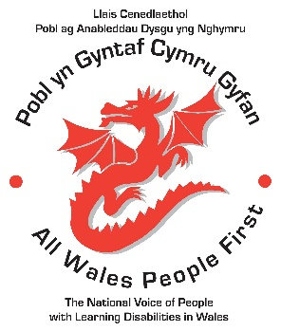
All Wales People First
Annual Conference 2017
Day 2: AdFest
Thursday 5th October

AdFest Delegate Booking form
We can accept bookings for AdFest delegate places until 20th September. There is limited space at the venue, so it is best to book early to avoid disappointment.

AdFest booking fees are for non-members who are attending day 2 of the All Wales People First Annual Conference on Thursday 5th October.
Day delegate fee:
£46 per person per day, to include lunch and refreshments.
AdFest Day Delegate Booking Form
AdFest – 5th October 9.30am-3pm
Book by 20th September – limited places

Group or organisation ………………………………………………………
Your name …………………………………………………………………..

Your address…………………………………………………………………

Post code……………………. Tel no…………………………

Emergency telephone number whilst at Conference…………………

Email address………………………………………………………………..

Do you have any specific needs?

Do you use a wheelchair? Do you need papers in Welsh
Do you need a Lip speaker? Do you need a hearing loop system
Do you need a BSL interpreter Do you need Papers in Braille
Do you need papers Large print Do you need Easy Read papers?
Do you need a Speech to text operator?
If you need a specific diet, please tell us what you need here: …………………………………………………………………………………………………
Please return your booking form and payment to:
All Wales People First,
2017 Annual Conference,
61 Caerleon Road
Newport
NP19 7BW
Cheques / postal orders: to be made payable to AWPF

