Carers Public Information Request Form

If you would like a hard copy version of the Bowel Screening Wales Carers booklet please fill in this request form and return it by post or email to the address below.

How would you like us to send your information pack? By post By email

Name and address for mailing or e-mailing the additional information:

Name:
Organisation:
Address:
Email:

How many booklets would you like?

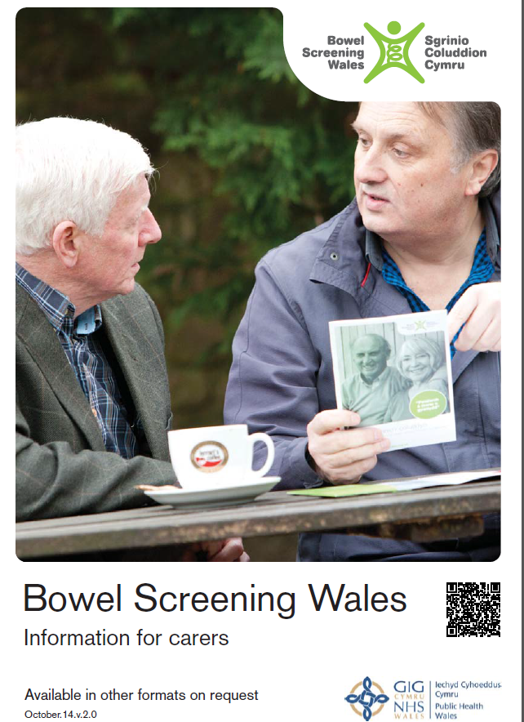  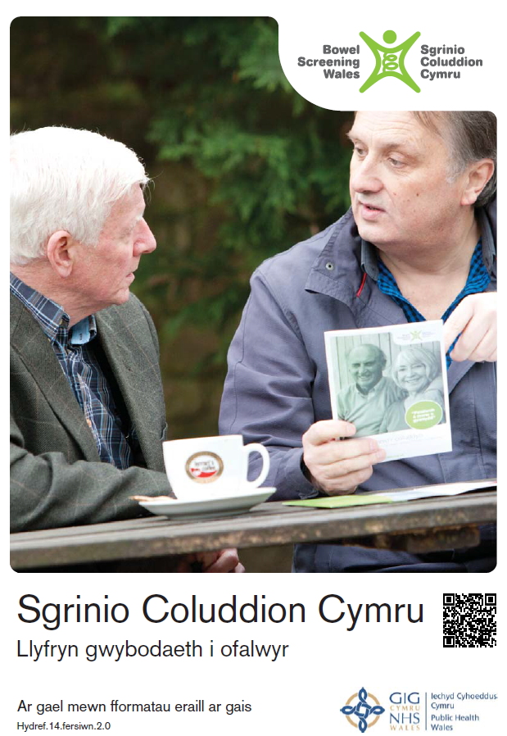  A5 Leaflet |  |  | 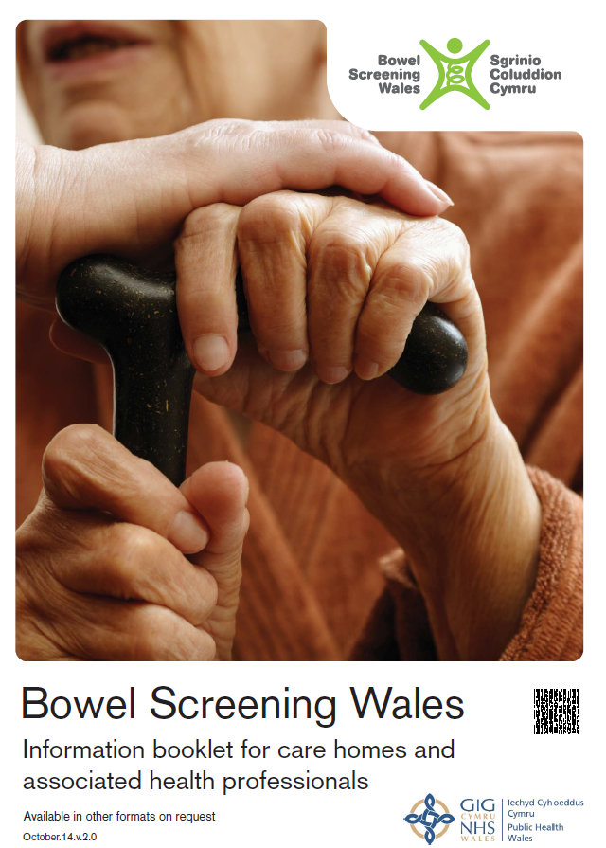  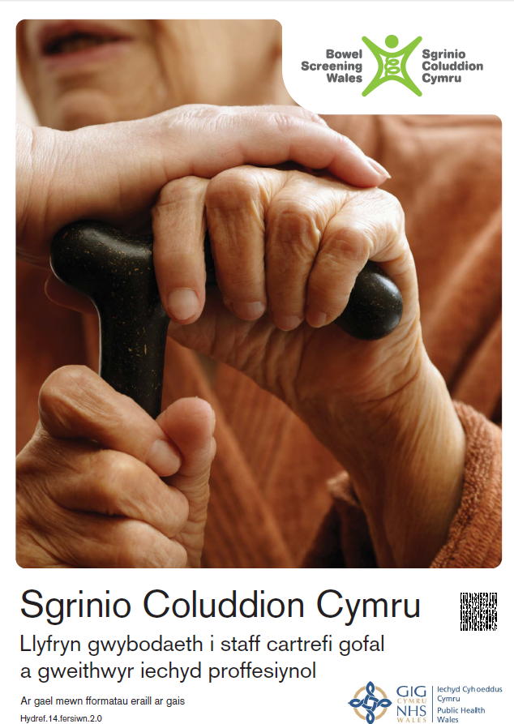  A4 Leaflet
How many?  Maximum of 5 |  |  | Electronic only

If you need more information on the above or would like a talk or presentation, please contact the Screening Engagement Team, c/o Breast Test Wales,
18 Cathedral Road, Cardiff. CF11 9LJ
Phone: 029 2078 7829 Fax: 029 2078 7800
Email: julie.roche@wales.nhs.uk

Gofalwyr Ffurflen gais Gwybodaeth gyhoeddus

Os hoffech gael fersiwn copi caled o'r llyfryn Gofalwyr Cymru Sgrinio Coluddyn llenwch y ffurflen gais hon a'i dychwelyd drwy'r post neu e-bost i'r cyfeiriad isod.

Ticiwch os hoffech i ni anfon eich pecyn gwybodaeth atoch drwy’r post
neu dros yr e-bost

Enw a chyfeiriad ar gyfer postio neu e-bostio’r wybodaeth ychwanegol:

Enw:
Sefydliad:
Cyfeiriad:
E-bost:

Ticiwch y blwch ar gyfer y pecynnau sydd eu hangen arnoch

Taflen A5 |  |  | Taflen A4
Faint o?  uchafswm o 5 |  |  | Electronig yn unig

Os oes angen rhagor o wybodaeth am yr uchod, neu os hoffech sgwrs neu gyflwyniad, cysylltwch â'r Tîm Ymgysylltu Sgrinio, d / o Bron Brawf Cymru,
18 Ffordd yr Eglwys Gadeiriol, Caerdydd. CF11 9LJ.
Ffôn: 029 2078 7829 Ffacs: 029 2078 7800
E-bost: julie.roche@wales.nhs.uk

