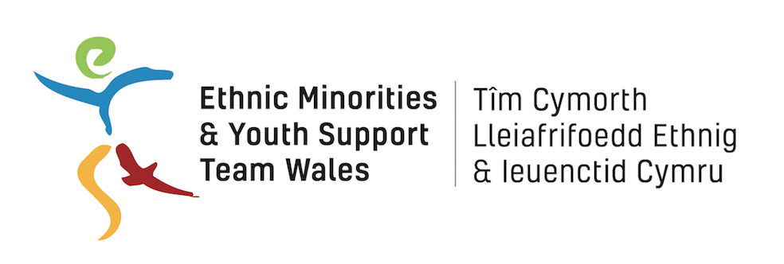

BME Skills Project Evaluation Specification

Invitation to Tender

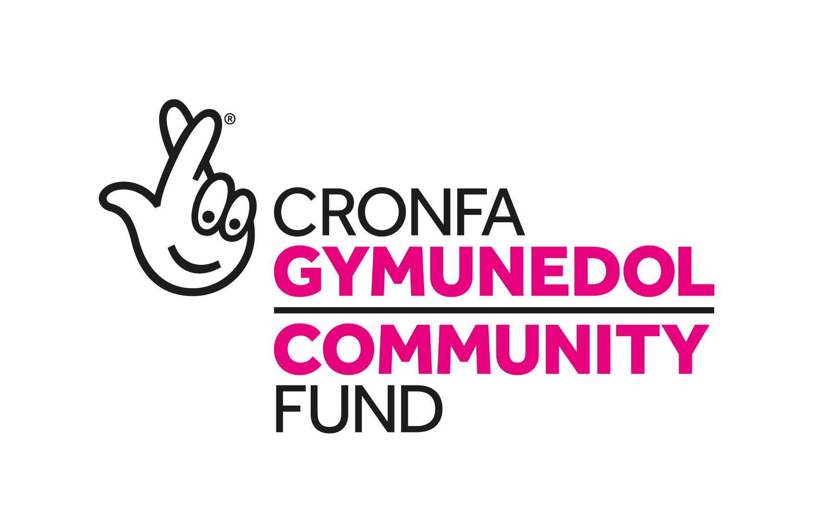

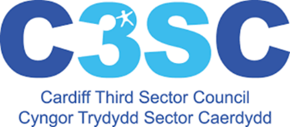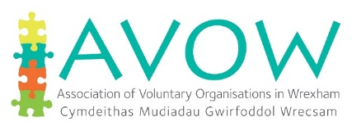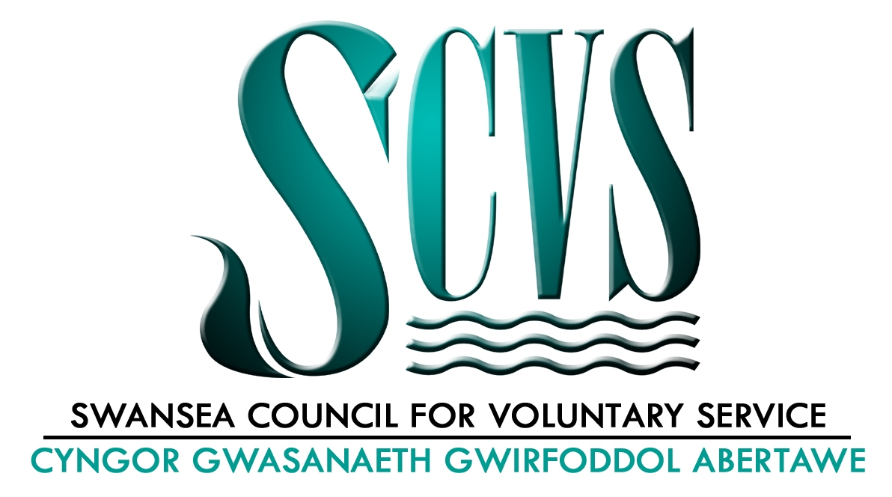
Tender Instructions

EYST Wales wishes to invite suitably qualified and experienced contractors to carry out an evaluation of the BME Skills Project as outlined in this document.

These instructions are designed to ensure that all tenderers are given equal and fair consideration. Tenderers should read these instructions carefully and ensure that all information asked for is provided. Failure to comply with these requirements for completion and submission may result in the rejection of the tender.

To enable evaluation of bids, tenderers are expected to provide a full proposal as part of their application and must address the contract award evaluation criteria detailed on page 9. Please also provide a pricing schedule based on the information given and the information to be supplied. This breakdown of costs (inclusive of VAT) should include costs per day and the total number of days to be allocated to the respective tasks and in total. It should include all costs associated with the preparation and execution of the written Final Evaluation Report. The schedule of costs should also include an estimate of incidental expenses covering travel expenses and overnight accommodation where it is required.

Tender submissions must not exceed 10 pages.

Please direct any questions or requests for further information to:

Rocio Cifuentes
CEO
EYST
Units B& C, 11 St Helens Road
Swansea,
SA1 4AB
01792 466980
rocio@eyst.org.uk

Your tender must be submitted by 12:00 noon on 24th July 2019. Any tenders submitted after the closing date will not be considered. An announcement of the decision will be made week commencing 29th July 2019.

Only those tenders that are compliant with this specification document will be evaluated.

Tenderers must obtain for themselves at their own responsibility and expense all information necessary for the preparation of the tender. Tenderers are solely responsible for the costs and expenses incurred in connection with the preparation of and submission of their tender and all other stages of the selection process. Under no circumstances will EYST, or any of their advisers, be liable for any costs or expenses borne by Tenderers, sub-contractors, suppliers or advisers in this process.

EYST Wales relies on Tenderers’ own analysis and review of information provided. Consequently, Tenderers are solely responsible for obtaining the information which they consider is necessary in order to make decisions regarding the content of their Tenders and to undertake any investigations they consider necessary in order to verify any information provided to them during the procurement process.

EYST Wales shall be under no obligation to accept the lowest or any Tender.

- Introduction
EYST Wales is a leading BME organisation and a registered charity which aims to support ethnic minority people across Wales. Established in Swansea in 2005, it has grown and developed into a Wales wide organisation, working to support ethnic minority young people, families, communities and individuals. Our vision is a country where BME people can participate, contribute, and be a valued part of Wales.
We have a long track record of delivering in Swansea and across Wales. Our experience includes employability and skills, community justice, youth and family support, and wellbeing programmes. We deliver a range of activities to people from ethnic minority backgrounds, including young people, families, community groups and refugees and asylum seekers. We also work with the wider community to address and challenge negative stereotypes and improve understanding of and attitudes towards ethnic minority groups.
Further information on EYST Wales can be viewed on our website www.eyst.org.uk
The BME Skills Project
EYST and partners SCVS, C3SC and AVOW have been funded by The National Lottery Fund to bring increased skills to the BME Third Sector in Wales. The aim of the BME Skills Project is to support smaller BME community groups and organisations to prosper by bringing the skills and experience of BME people in the private sector and young graduates into the community sector, as Volunteer Mentors, including as Trustees. The project aims to engage with private and public sector employers and universities to recruit and engage with the intended target group of BME professionals and young graduates with specific skills to offer community groups.
The project is led by EYST Wales, who employs the Project Coordinator. Project officers are based in and employed by SCVS in Swansea, C3SC in Cardiff, and AVOW in Wrexham and directly engage with and provide support to BME community groups in their respective areas by:
• Undertaking an asset-based organisational diagnostics with each community group
• Identifying their strengths and potential (asset-based approach, not deficit-based)
• Matching them to a potential Mentor/ Trustee
• Offering short-term placements/ tasters on more established Boards
• Offering community leadership training to improve confidence of emerging community leaders.
Beneficiary groups & organisations are identified by the CVCs’ existing established networks as well as identified through EYST’s wider work and specific links to BME communities.

The project’s four main outcomes are:

- Outcome 1: More Resilient and Sustainable BME Community Organisations
BME Community Organisations are more resilient and sustainable, with increased confidence, improved understanding of their strengths and weaknesses, and clear plans to achieve their goals.

- Outcome 2: Stronger Governance for BME organisations
BME Community Organisation have more skilled and professional trustees, with relevant skills to improve governance and sustainability of the organisation.

- Outcome 3: Improved Support for BME organisations
BME Community organisations will have access to trained community mentors who will bring a range of skills to their organisations.

- Outcome 4: Better connections for BME organisations
CVCs and other Third Sector organisations will improve their understanding of the needs of BME organisations and increase their accessibility and connections to BME community groups.

- Evaluation Requirements

EYST Wales wishes to appoint a suitably qualified and experienced contractor to carry out a detailed evaluation of the BME Skills Project in order to meet The National Lottery funding requirements. The evaluation will also assist EYST Wales to assess the effectiveness and impact of the BME Skills project over the three-year period with a view to enhancing and informing future capacity building programmes beyond the project lifetime.

We expect the Interim and End of Project Evaluations to assess the outcomes and impact of the project, the difference made and identify best practice and lessons learnt. The final evaluation will also make recommendations on how the project could be developed further and disseminated at Welsh and UK levels.

We expect the evaluator to explore the issues outlined below over the course of the evaluation:
- The rationale, need and relevance of the BME Skills project and extent to which project is meeting its expected outcomes;
- The appropriateness and effectiveness of the project’s delivery arrangements (including the involvement of partners) including strengths and weaknesses;
- The quality and appropriateness of project provision and extent to which the project activities fulfil requirements;
- The efficiency and effectiveness of project processes and management, including monitoring systems deployed and reporting mechanisms;
- The effectiveness of project promotional activity/processes and the contribution played by stakeholders in recruiting beneficiaries;
- The extent to which the project is on-track to achieving its funded outcomes and reasons for any under/over performance;
- Direct impacts and difference made to project beneficiaries – including any changes as a result of participation;
- Wider impacts and the difference made to project partners’ and stakeholders’ organisations and services.
- The cost-effectiveness and value for money offered by the project and the extent to which the project has added value to partners’ provision;
- Project achievements and lessons learned, including ways of improving future delivery;
- The extent to which outcomes achieved (for participants and partners) have been sustained over time.
- Making recommendations on how project achievements and lessons can be disseminated at Welsh and UK levels.

The successful bidder will have access to the following documentation/reports over the course of the evaluation:

- TNL Lottery Fund Application and Project Business Plan
- Six monthly progress reports and Annual progress reports prepared for the TNL Fund.
- Minutes of project steering group meetings
- Project promotional material
- Workshop training materials
- Beneficiary sign up and tracking forms
- Any other relevant project material

We expect bidders to suggest an appropriate methodology for undertaking the evaluation but anticipate that it is likely to include the elements outlined below. We would welcome approaches that would incorporate a Results Based Accountability or similar evaluation framework:

- Inception Phase
- Desk Based Analysis of project documentation and monitoring data
- A light touch literature review and identification of other relevant research and alignment with key policy areas
- The gathering of baseline data and identification of external indicators from which to measure the impact of the project
- Preparation of discussion guides/questionnaires to inform evaluation fieldwork
- Observation of project delivery / mentoring activity
- Qualitative fieldwork with a sample of Project Beneficiaries (before and after intervention) as well as more longitudinal research
- Qualitative fieldwork (face to face, phone or group based) with project staff, project partners and other stakeholders
- Case study material
- Reporting, Presentation and Dissemination

- Budget

The maximum budget for this project evaluation tender is £9,000 (including VAT), of which we would expect to pay 50% upfront, and 50% on satisfactory completion of the work.

- Reporting and Disseminating

Reporting Dates
An Inception Report, outlining a detailed workplan for the evaluation will be required following an Inception meeting with the client and formal awarding of the contract, during August 2019.

An Interim Evaluation Report will need to be submitted in January 2020 with a Final Evaluation Report (including a bilingual Executive Summary) submitted in December 2020.

The successful contractor will also be expected to present the main findings of the Interim Evaluation to the Project Steering Group during March 2020, and at the End of project conference in November 2020.

- Timetable/Milestones

The following table highlights the key expected milestones for the project evaluation.

Milestone | Date
Deadline for receipt of Tenders | 24th July 2019
Contract Awarded | w/c 29th July 2019
Inception Meeting | w/c 5th August 2019
Submission of Inception Report | October 2019
Submission of Interim Evaluation Report | January 2020
Presentation of Draft Report to Steering Group | March 2020
Submission of Draft Final Evaluation Report | October 2020
Meeting to review Draft Report | November 2020
Presentation of Final Evaluation Report at End of Project Conference | November 2019
Submission of Final Evaluation Report | December 2020

- Data Protection, Confidentiality and Copyright

All information supplied by EYST Wales in connection with this proposal submission is to be regarded as confidential by the organisation submitting the proposal.

EYST assumes that applicants accept these instructions on the basis that all materials, when produced, will become the property of EYST Wales.

The evaluation will involve the processing of personal data and the successful Contractor will be acting as data processor on behalf of EYST Wales. All processing of data undertaken by the Contractor on EYST Wales’ behalf must be in compliance with the requirements of the Data Protection Act 1998 and the General Data Protection Regulations 2018.

- Contract Award Criteria

The contract will be awarded on the basis of the most economically advantageous tender in terms of value for money and on the basis of the following criteria:

- Experience and expertise of conducting evaluations and producing external evaluation reports for a range of audiences;
- Effective proposed methodology and approach to the evaluation;
- Previous experience of undertaking fieldwork with the target beneficiary group
- In-depth understanding and expertise of the subject area
- An appreciation of the aims and objectives of the BME Skills Project;
- Capacity and resources to deliver the evaluation on time and on budget
- Ability and flexibility to support EYST Wales and the project steering group in the development of the project and dissemination of lessons learnt.
- Cost (Must be under the maximum budget available).

Tenderers are advised to provide a full proposal which:

- Addresses the evaluation criteria outlined above
- Includes brief profiles and roles for staff who would work on the evaluation
- Includes two previous referees (including organisation’s name, contact person and job role, address and contact number
- Includes a price for undertaking each phase of work.
- Is no longer than 10 A4 pages (no smaller than 11 sized font).

- Contract Management

The successful contractor will be expected to monthly e-mailed progress reports to Rocio Cifuentes, CEO at EYST during live periods of the evaluation and attend regular meetings with the EYST CEO and/or BME Skills Project Coordinator Nathan Evans as and when required.

- Changes to the Project Evaluation Specification

This Project Evaluation Specification sets out our current service requirements. It is possible that during the life of the contract that changes, for example, in the nature of timescales or other requirements will arise. Changes to the Project Evaluation Specification will be implemented by issuing written amendments to those affected by the changes.

