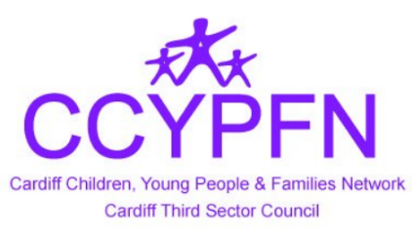

Cardiff Children, Young People and Families Network
Wednesday 20 June 2018
10:00 to 12:00
Oasis Cardiff
69b Splott Rd, Cardiff, CF24 2BW

Agenda

1. Welcome & Introductions
2. Oasis Centre – Reynette Roberts
3. Family Needs Fathers / Both Parents Matters – Anne O’Regan
4. Education Development Board, Third Sector Rep - Anthony Houlston Clark
5. Next Meeting
6. Any Other Business
7. Networking
To attend, please contact Natasha Applasamy:
natasha.a@c3sc.org.uk
02920 485722
07973725477

