C3SC Annual Meeting – Feedback Surveys
27th November 2018

C3SC is keen to hear from members about the quality of our services and events. Your feedback, which will help to shape our development of infrastructure support for the third sector in Cardiff, can be provided in a range of ways.
- Event evaluation: A form is provided within the event pack for you to give your feedback; alternatively, you can give your view about today’s event online: https://goo.gl/forms/xl9butTSnRPGxMGl2

- C3SC Members Survey - help shape our delivery: Forms are available at the C3SC stand. Copies are also available online: https://goo.gl/forms/6nD2xeU9iVNLQYI93

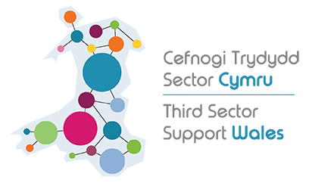
- C3SC TSSW Impact survey
Third Sector Support Wales (TSSW) is a network of support organisations for the third sector in Wales, comprising C3SC, Wales’ other County Voluntary Councils and Wales Council for Voluntary Action. Our shared goal is to enable to third sector and volunteers across Wales to contribute fully to individual and community wellbeing, now and for the future. To help us with this goal, we would appreciate it if you could complete a short survey. It asks a number of questions about how local TSSW organisations (i.e. C3SC) have assisted your organisation in areas such as governance, funding, volunteering and influencing. The survey should only take around five minutes to complete and will help TSSW plan for the future and improve how it works with and supports third sector organisations across Wales. The survey is also available here: https://www.surveymonkey.co.uk/r/VZMFD5X

- Throughout the year, C3SC runs a range of events and themed networks, including a members’ forum at the Annual Members meeting - a Q&A session for members with the Board and Management Team.

- Engaging Online:
#C3SCAGM2018 #WellbeingInAction

